# A

**Project Report On**

“SMART CANTEEN”

**MCA113-MINI PROJECT**

By

“Piyush Kulbhushan Adake” “3123015010194”

**Mini Project work carried out at**

**Faculty of Commerce and Management**



**VISHWAKARMA UNIVERSITY PUNE**

December 2023

**DECLARATION**

I, the undersigned, hereby declare that the project report entitled **“Smart Canteen”** written and submitted by me to Vishwakarma University, Pune in partial fulfillment of the requirement for Mini Project (Semester I) as part of two year full-time MCA programme. The project is for academic purposes only. This is the original work of the undersigned and has not been reproduced from any other sources.

Signature:

Name of the Student: **Piyush Kulbhushan Adake**

PRN: **3123015010194**

Date:

Place : **Vishwakarma University, Pune**

## Mini Project Completion Certificate MCA Programme

**Batch : 2023-2025**

This is to certify that **Mr. Piyush Kulbhushan Adake,** student of Master of Computer Application (MCA) Programme under Faculty of Commerce and Management at Vishwakarma University, Pune, has completed the Mini Project titled **Smart Canteen** as per university guidelines for the two-year full-time MCA programme.

Faculty Guide (Name): **Prof. Yogesh Desale**

Faculty Guide (Signature):

## ACKNOWLEDGEMENTS

This project would not have been possible without the support of many people. I would like to acknowledge and extend my heartfelt gratitude to the following persons who have made the completion of this project possible.

My Supervisor, **Prof. Yogesh Desale** for his full support and guidance throughout this project. My additional examiner **Ms.Gauri Kulkarni** for reviewing project and helping me in design. My dean **Dr. Jayashree Vispute** for encouraging and supporting me to pursue the project.

I also thank to Vishwakarma University, Pune team for step by step updating regarding project with nice taxila support.

My team members who have helped me during various phases of the project. Last but not the least; I would like to express my love and gratitude to my beloved family, for their understanding & motivation, through the duration of this project.

## ABSTRACT

The main moto of the Project on Canteen Management System is to manage the details of Canteen, Employee, Item, Stock, Sales. It manages all the information about Canteen, Customer, Sales, and Canteen. The project is totally built at administrative end and thus only the administrator is guaranteed the access.

**Key words:** Digital menu system, Information about available, Food items Real-time prices

## Signature of the Student Signature of the Supervisor

**Name: Piyush Kulbhushan Adake Name: Prof. Yogesh Desale**

## Date: Date:

**Place: Pune Place: Pune**

## Table of Contents

Chapter 1: Introduction

1. What is JavaWeb Application… 1
   1. Overview of the Smart Canteen JavaWebApplication. 1
   2. Importance of Smart Canteen Solutions. 2

Chapter 2: System Analysis

* 1. Understanding the Current Canteen System. 4
  2. Proposed Smart Canteen System. 5

Chapter 3: Software and Hardware Requirements

* 1. Software Specifications for Smart Canteen WebApplication. 6
  2. Hardware and Software Specifications for Efficient Deployment. 7

Chapter 4: Selected Technologies

* 1. Java Web Technologies: Overview and Advantages. 8
  2. Database Management System for Smart Canteen. 10
     1. Benefits of the MySql Database Management System. 11
  3. Frameworks and Tools for Development. 13

Chapter 5: System Design

* 1. UML Diagrams of Smart Canteen Application. 14
     1. ERD Diagram for Smart Canteen Application. 16
     2. DFD Diagram for Key System Components. 19
     3. Class Diagram for System Processes. 20
     4. Use Case Diagram for Key Interactions. 21

Chapter 6: System Implementation

* 1. Implementation Strategy for Smart Canteen Application. 22
  2. Java Source Code Samples… 24
  3. Integration of Security Measures. 31

Chapter 7: System Testing

* 1. Unit Testing of Modules and Functionalities. 32
  2. Integration Testing for Seamless Operations. 33

Chapter 8: User Interface Samples

* 1. Homepage of Smart Canteen Application. 34
  2. User Registration and Profile Setup. 34
  3. Login Interface for User… 35
  4. Add Menu Screens. 35
  5. Add Employee Screens. 36
  6. Order Confirmation… 36

Conclusive and Future Enhancement… 37

Biblography 39

Checklist of items for the for Final dissertation Report. 40

## Table of Figures

Fig 1: ERD Diagram… 16

Fig 2: DFD Diagram… 19

Fig 3: Class Diagram… 20

Fig 4: UseCase Diagram 21

Fig 5: Homepage 34

Fig 6: Registration 34

Fig 7: Login 35

Fig 8: Add Menu 35

Fig 9: Add Employee 36

Fig 10: Order Confirmation 36

# Chapter 1: Introduction

## What Is JavaWeb Application

Java Web Application is used to create dynamic websites. Java provides support for web application through Servlets and JSPs. We can create a website with static HTML pages but when we want information to be dynamic, we need web application.

The aim of this article is to provide basic details of different components in Web Application and how can we use Servlet and JSP to create our first java web application.

A Java Web Application is an application that uses the Java programming language to perform tasks on a web server or through a web browser. It's a software application that is accessed through a web browser and typically runs on a web server.

1. **Back-end Logic:** Java code runs on the server-side to manage the application's functionality. This can include handling user requests, interacting with databases, processing data, and generating dynamic content.
2. **Front-end Presentation:** The application's user interface is typically built using technologies like HTML, CSS, and JavaScript. Java often generates dynamic content that is then rendered on the user's browser.
3. **Servlets and JSP (JavaServer Pages):** These are the key components used in Java Web Applications. Servlets are Java classes that handle HTTP requests and generate responses. JSP is a technology used to create dynamic web pages by embedding Java code in HTML.

## Overview of the Smart Canteen JavaWebApplication

The main objective of the Project on Canteen Management System is to manage the details of Canteen, Employee, Item, Stock, Sales. It manages all the information about Canteen, Customer, Sales, and Canteen. The project is totally built at administrative end and thus only the administrator is guaranteed the access. The purpose of the project is to build an application program to reduce the manual work for managing the Canteen, Employee, Customer, and Item. It tracks all the details about the Item, Stock, and Sales. The objective of the smart canteen project is to revolutionize the traditional concept of

canteens by incorporating smart technology and innovative solutions. The primary goal is to enhance the overall dining experience for customers while streamlining operations and improving efficiency. One of the key objectives is to implement a cashless payment system within the canteen. By introducing smart cards or mobile payment options, customers can conveniently make transactions without the hassle of carrying cash. This not only reduces waiting times but also ensures a secure and seamless payment process. Another objective is to introduce a digital menu system that provides realtime information about available food items, prices, and nutritional details. This empowers customers to make informed choices based on their dietary preferences or restrictions.

## Importance of Smart Canteen Solutions

Smart Canteen Solutions streamline the entire canteen operation, from ordering to delivery, minimizing waiting times and optimizing the overall process. Through automated ordering systems and digital payment methods, it significantly reduces queues and waiting times, enhancing the overall efficiency of the canteen.

By providing a user-friendly interface for customers to place orders, personalize preferences, and make cashless transactions, Smart Canteen Solutions elevate the customer experience. Users can enjoy convenient and quick access to a variety of menu items while reducing the hassles of traditional cash-based transactions.

These solutions often come equipped with analytics tools that gather data on customer preferences, popular items, peak hours, etc. This data can be analyzed to make informed decisions, optimize inventory, adjust menu offerings, and improve overall operations.

Implementing Smart Canteen Solutions can potentially reduce overhead costs by streamlining operations, cutting down on wastage, and optimizing inventory management. This ensures better resource allocation and cost-efficiency in the canteen's day-to-day functioning.

Adaptability and Scalability solutions are designed to adapt and scale according to the needs of the institution or facility. Whether it's catering to a small-sized school or a large corporate campus, Smart Canteen Solutions can be tailored to accommodate different scales of operation.

Integration of Technology Introducing such solutions aligns with the modern technological landscape, catering to the preferences of tech-savvy users. It not only keeps pace with technological advancements but also reflects an institution's or organization's commitment to innovation and convenience for its members or employees.

The importance of Smart Canteen Solutions lies in revolutionizing the traditional canteen experience, offering a seamless, efficient, and tech-driven approach to catering services within various environments such as educational institutions, corporate offices, or public facilities.

# Chapter 2: System Analysis

## Understanding the Current Canteen System

Understanding the current canteen system is a pivotal step in the development of a transformative Smart Canteen Solution. It involves a comprehensive exploration of the canteen's operations, workflow, and technological framework. This in-depth analysis scrutinizes the entire process, from order placement to food preparation, payment handling, and customer service.

By immersing into the operational workflow, one gains insight into the intricacies of how orders are managed, inventory is maintained, and services are delivered. It involves an assessment of existing technological tools, such as point-of-sale systems or inventory management software, to evaluate their efficacy in optimizing processes.

Equally important is comprehending the customer experience within the canteen. This includes understanding customer pain points, whether related to long queues, complexities in placing orders, payment hassles, or any other issues affecting their satisfaction.

Furthermore, scrutinizing resource utilization, including human labor, ingredients, equipment, and space, is crucial. This analysis reveals opportunities for streamlining operations and enhancing efficiency. Soliciting feedback from canteen staff and users provides invaluable perspectives, shedding light on operational strengths and areas requiring improvement.

This thorough understanding of the current canteen ecosystem serves as the bedrock for devising a Smart Canteen Solution that not only addresses identified challenges but also elevates operational efficiency, enriches customer experiences, and integrates innovative technology to propel the canteen environment into a modernized and optimized state.

**Static Menus**: Traditional canteens often have fixed menus that change infrequently. These menus are typically displayed on menu boards or printed menus.

**Food Preparation**: Food is prepared by kitchen staff based on orders received at the counter. The cooking process may not always be optimized for efficiency or

sustainability.

**Limited Information**: Customers may have limited access to nutritional information or ingredient details, making it challenging to make informed dietary choices.

## Proposed Smart Canteen System

The proposed Smart Canteen System aims to revolutionize the traditional canteen experience by introducing a technologically advanced and user-centric solution. This innovative system will leverage cutting-edge technology to streamline operations, enhance efficiency, and elevate the overall customer experience within the canteen environment.

At its core, the Smart Canteen System will offer a seamless and intuitive ordering process, allowing users to place orders through a user-friendly interface accessible via web or mobile applications. It will incorporate features for personalized preferences, quick order placement, and secure digital payment methods, reducing waiting times and ensuring convenience for patrons.

Moreover, this system will integrate sophisticated backend functionalities, utilizing technologies such as Java web applications, database management systems, and efficient frameworks for robust performance. Analytics tools will provide valuable insights into customer preferences, enabling optimized inventory management and informed decision- making.

The proposed system will not only address existing challenges observed in the current canteen setup but also set new standards for operational efficiency and customer satisfaction. By embracing technology-driven solutions, the Smart Canteen System aspires to create a modern, efficient, and user-centric environment that caters to the evolving needs of patrons while optimizing resource utilization and fostering a seamless dining experience.

Static Menus: Fixed menus with limited options can become monotonous, and they may not cater to changing dietary preferences, cultural diversity, or seasonal ingredients.

Waste Generation: Manual ordering and food preparation can result in overproduction and food waste, contributing to environmental concerns.

# Chapter 3: Software and Hardware Requirements

## Software Specifications for Smart Canteen Application NetBeans IDE :

NetBeans IDE is a free, open source, integrated development environment (IDE) that enables you to develop desktop, mobile and web applications

.The IDE supports application development in various languages, including Java, HTML5, PHP and C++.

The IDE provides integrated support for the complete development cycle, from project creation through debugging, profiling and deployment.

The IDE runs on Windows, Linux, Mac OS X, and other UNIX-based systems.

The IDE provides comprehensive support for JDK 7 technologies and the most recent Java enhancements. It is the first IDE that provides support for JDK 7, Java EE 7, and JavaFX 2. The IDE fully supports Java EE using the latest standards for Java, XML, Web services, and SQL and fully supports the GlassFish Server, the reference implementation of Java EE.

## Java Development Kit (JDK):

Install the JDK on your system, as it is required to write and run Java code. We can download the JDK from the Oracle website and follow the installation instructions.

## MySQL Workbench:

MySQL Workbench is a visual tool for database design,

development, and administration. It allows you to create and manage databases, tables, and queries

## Hardware and Software Specifications for Efficient Deployment Software requirements-

**Operating System :-**

Windows 7 or newer, macOS X v10.7 or higher, or Linux (Ubuntu).

## Java Development Kit (JDK):

Install the latest version of JDK, which includes the Java Runtime Environment (JRE) needed to run Java applications.

## Web Server:

We will need a web server to deploy your Java web application

## Hardware Requirements- Processor:

Minimum 1 GHz; Recommended 2 GHz or more

## Memory (RAM):

Minimum 2 GB; Recommended 4 GB or above

## Hard Drive :

Minimum 32 GB; Recommended 64 GB or more

# Chapter 4: Selected Technologies

## Java Web Technologies: Overview and Advantages

Java web technologies encompass a wide array of tools and frameworks used in web development, known for their reliability, scalability, and versatility. At the core of these technologies lie JavaServer Pages (JSP), Servlets, and frameworks like Spring MVC and JavaServer Faces (JSF).

JavaServer Pages (JSP) allows the creation of dynamic web content by embedding Java code within HTML. Servlets, on the other hand, are Java classes that handle requests and generate responses on the server-side, facilitating interaction between web servers and clients.

Frameworks such as Spring MVC offer a comprehensive infrastructure for developing Java web applications, providing features like inversion of control (IoC), aspect-oriented programming (AOP), and robust support for RESTful services. JavaServer Faces (JSF) simplifies building user interfaces for web applications through reusable UI components.

The advantages of using Java web technologies are manifold. Java's platform independence enables applications to run on various operating systems without modification, ensuring compatibility and flexibility. Its vast standard library and robust security features contribute to creating secure and stable web applications. Additionally, the scalability and performance optimization capabilities of Java make it suitable for handling large-scale web applications, ensuring reliability even under heavy user loads.

Java web technologies offer a powerful ecosystem for developing web applications, empowering developers to create feature-rich, scalable, and secure solutions for diverse business needs.

The inherent advantages of Java web technologies lie in their platform independence, allowing applications to run seamlessly on various platforms without modification. Java's extensive standard library and built-in security features ensure a secure development environment, guarding against vulnerabilities and threats.

* Java's "Write Once, Run Anywhere" philosophy allows developers to create web applications that can run on various platforms without modification. This platform independence is crucial for scalability, as it enables businesses to adapt and expand their services across different operating systems, devices, and cloud environments.
* This flexibility ensures that your web application can reach a broader audience and adapt to changing technology landscapes effortlessly.

A Java web framework provides a set of APIs and tools that can be used to develop web applications more easily and efficiently. There are a number of different Java web frameworks available, such as Spring Boot, Hibernate, and JSF. The best Java web framework for a particular web application will depend on its specific requirements.

A stateless web application is one that does not maintain any state information between requests. Statelessness makes it easier to scale a web application because it allows multiple servers to handle requests without having to coordinate with each other.

Asynchronous programming is a technique that allows a web application to perform multiple tasks at the same time. This can improve the performance and scalability of a web application by allowing it to handle more requests concurrently.

Caching is a technique that stores frequently accessed data in memory so that it can be retrieved quickly without having to access the database or another data source. Caching can significantly improve the performance and scalability of a web application.

Java applications are highly scalable and can handle large loads of traffic. This is due to the Java Virtual Machine (JVM), which manages memory and resources efficiently.

Java is a secure language with many built-in security features. This includes sandboxing, which isolates Java applications from each other and the underlying operating system.

Java is a platform-independent language, which means that Java applications can run on any operating system that has a JVM installed. This makes Java ideal for developing web applications that need to be accessible to a wide range of users.

Java is an object-oriented language, which makes it easy to develop modular and reusable code.

## Database Management System for Smart Canteen

The Database Management System (DBMS) plays a pivotal role in the Smart Canteen Solution, and MySQL stands as a robust choice due to its versatility, reliability, and widespread adoption in web-based applications.

MySQL, an open-source relational database management system, offers several advantages that make it well-suited for the Smart Canteen environment. Its relational structure facilitates efficient organization and management of data, ensuring seamless integration with Java-based web applications.

MySQL's scalability allows it to handle a substantial volume of data and transactions, vital for managing diverse canteen operations, including user accounts, menu items, orders, and transaction records. Additionally, its performance optimization features contribute to faster data retrieval and processing, crucial for ensuring quick and responsive interactions within the canteen system.

Its compatibility with various operating systems and hosting environments simplifies deployment, offering flexibility and ease in integrating with Java web applications. Additionally, MySQL's security features, including access control mechanisms and encryption support, bolster the system's defense against unauthorized access or data breaches, vital for safeguarding sensitive information within the canteen system.

Using MySQL Workbench, you can visually design this database structure by creating tables, defining relationships between them (using primary and foreign keys), and specifying appropriate data types and constraints for each field. It allows you to create ER (Entity- Relationship) diagrams, facilitating a clear visualization of how the tables relate to each other.

Once the database structure is established, MySQL Workbench allows for the creation of queries, stored procedures, and triggers to manipulate and manage the data effectively. This tool also supports the implementation of security measures and backups to ensure data integrity and reliability within the Smart Canteen's database system.

**Users Table**: Store information about canteen users (e.g., students, staff, customers). Fields: User_ID (Primary Key), Name, Email, Password, Role, etc.

**Menu Items Table**: Hold details of available food items in the canteen. Fields: Item_ID (Primary Key), Item_Name, Description, Price, Category, etc.

**Orders Table**: Track individual orders placed by users.

Fields: Order_ID (Primary Key), User_ID (Foreign Key), Date_Time, Total_Price, Status, etc.

**Order_Items Table**: Store items within each order.

Fields: Order_Item_ID (Primary Key), Order_ID (Foreign Key), Item_ID (Foreign Key), Quantity, Subtotal, etc.

## Benefits of the MySql Database Management System

* + - 1. **Open Source and Cost-effective:** MySQL is an open-source DBMS, providing cost advantages for businesses. Its community edition is free to use, making it a cost- effective solution, especially for startups and small-scale implementations like a smart canteen.
      2. **Scalability and Performance:** MySQL is known for its scalability, allowing seamless handling of a large volume of data and transactions. Its performance optimization features ensure quick data retrieval, efficient storage, and smooth operations even during peak usage.
      3. **Reliability and Stability:** With years of development and refinement, MySQL has established itself as a stable and reliable database solution. It's extensively tested, ensuring robustness and minimal chances of system failure.
      4. **Flexibility and Compatibility:** MySQL is compatible with various operating systems, making it highly flexible for deployment across different platforms. It integrates well with different programming languages, frameworks, and tools, offering developers a wide range of options for system implementation.
      5. **Security Features:** MySQL provides multiple security features, including access controls, encryption support, and user authentication mechanisms, ensuring data privacy and protection against unauthorized access or data breaches. It complies with industry standards to meet security requirements effectively.
      6. **Community Support and Resources:** Being open source, MySQL has a vibrant community of developers and users who actively contribute to its development. This leads to a vast array of resources, including forums, documentation, tutorials, and third-party tools, facilitating easier troubleshooting and knowledge sharing.
      7. **Transaction Support and ACID Compliance:** MySQL ensures data integrity by supporting transactions and adhering to ACID (Atomicity, Consistency, Isolation, Durability) properties. This ensures that transactions are processed reliably and maintain consistency within the database.
      8. **High Performance and Optimization**: MySQL offers various performance optimization techniques such as indexing, caching mechanisms, query optimization, and storage engine options. These features enhance database performance, allowing for faster data retrieval and query execution.
      9. **Replication and High Availability**: MySQL supports replication, enabling the creation of multiple copies of the database for backup and load balancing purposes.

## Frameworks and Tools for Development

In the development of a Smart Canteen web application using NetBeans IDE, the choice of frameworks and tools significantly influences the application's efficiency, aesthetics, and functionality. Leveraging HTML, Bootstrap, CSS, and MySQL within the NetBeans environment brings forth a powerful combination to create a user-friendly, responsive, and robust system.

**HTML (HyperText Markup Language):** As the fundamental structure of web pages, HTML forms the backbone of the application. NetBeans IDE provides a convenient platform for HTML coding, enabling the creation of the application's structure, layout, and basic functionalities. HTML5 features supported in NetBeans allow for semantic structuring, audio/video embedding, and form validation, enhancing the application's user experience.

**Bootstrap:** Bootstrap, a front-end framework, offers a collection of pre-built design components and responsive layouts. Integrating Bootstrap with HTML and CSS in NetBeans enables rapid prototyping and simplifies the development of a mobile-friendly and visually appealing interface. Its grid system, components, and JavaScript plugins streamline the creation of a consistent and adaptable UI for the Smart Canteen application.

**CSS (Cascading Style Sheets):** CSS plays a pivotal role in styling the application's elements created with HTML. NetBeans provides a robust environment for CSS coding, allowing developers to define the application's visual presentation, including colors, fonts, layouts, and responsive designs. By leveraging CSS preprocessors and NetBeans' CSS editor, developers can efficiently manage and organize style rules for a cohesive and polished appearance across the application.

**MySQL:** MySQL, an open-source relational database management system, integrates seamlessly with NetBeans, enabling efficient data management and storage for the Smart Canteen application. NetBeans IDE provides tools for MySQL integration, allowing developers to design database schemas, write SQL queries, manage data, and establish connections to ensure the secure storage and retrieval of canteen-related information.

NetBeans IDE's comprehensive support for HTML, Bootstrap, CSS, and MySQL streamlines the development process by offering a conducive environment for coding, debugging, and testing. This combination of tools and frameworks empowers developers to create a

# Chapter 5: System Design

## UML Diagrams of Smart Canteen Application

Unified Modeling Language or UML Diagrams are used to represent the system diagrammatically.

## ERD Diagram for Smart Canteen WebApplication

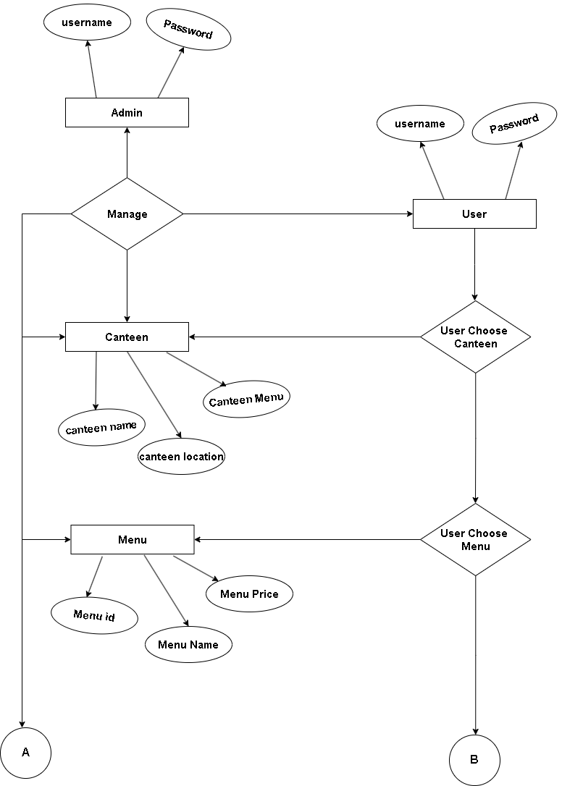**14**

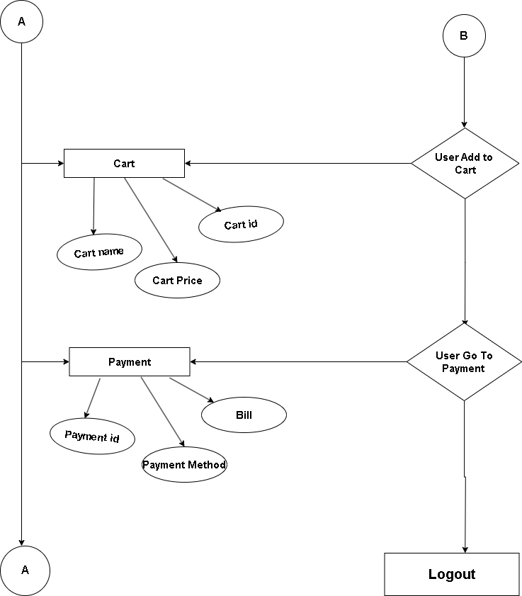

## DFD Diagram for Key System Components

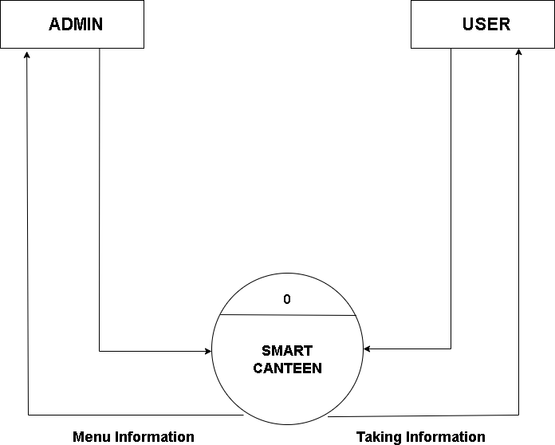

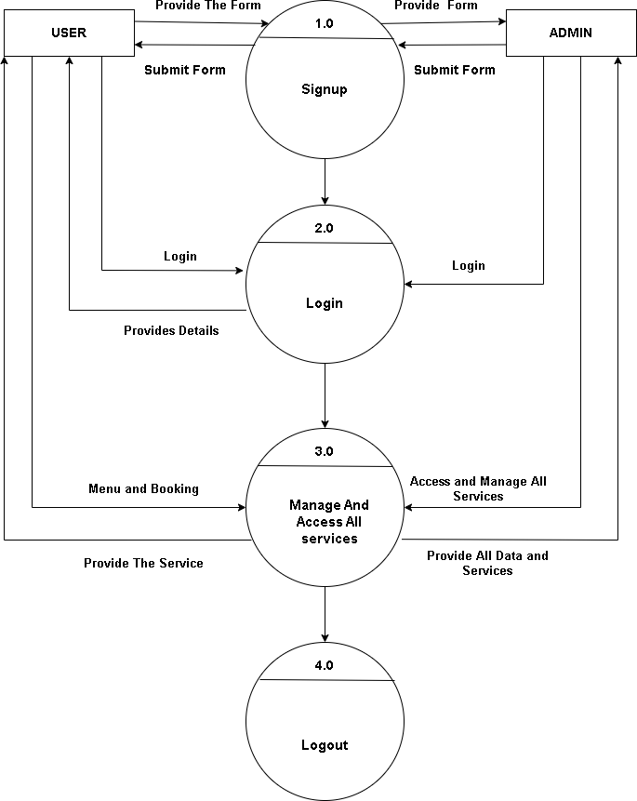

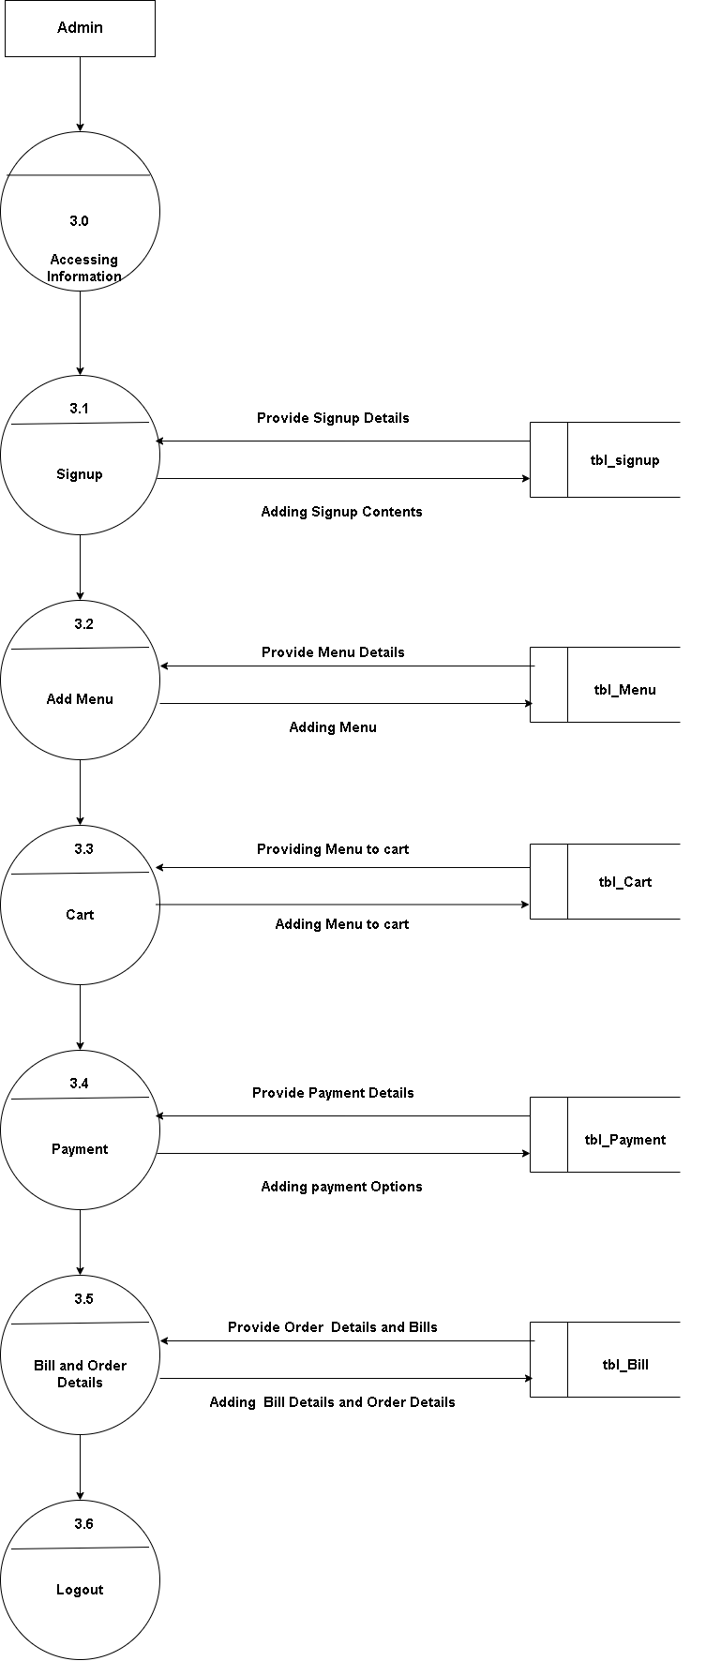

**18**

## Class Diagram for System Processes

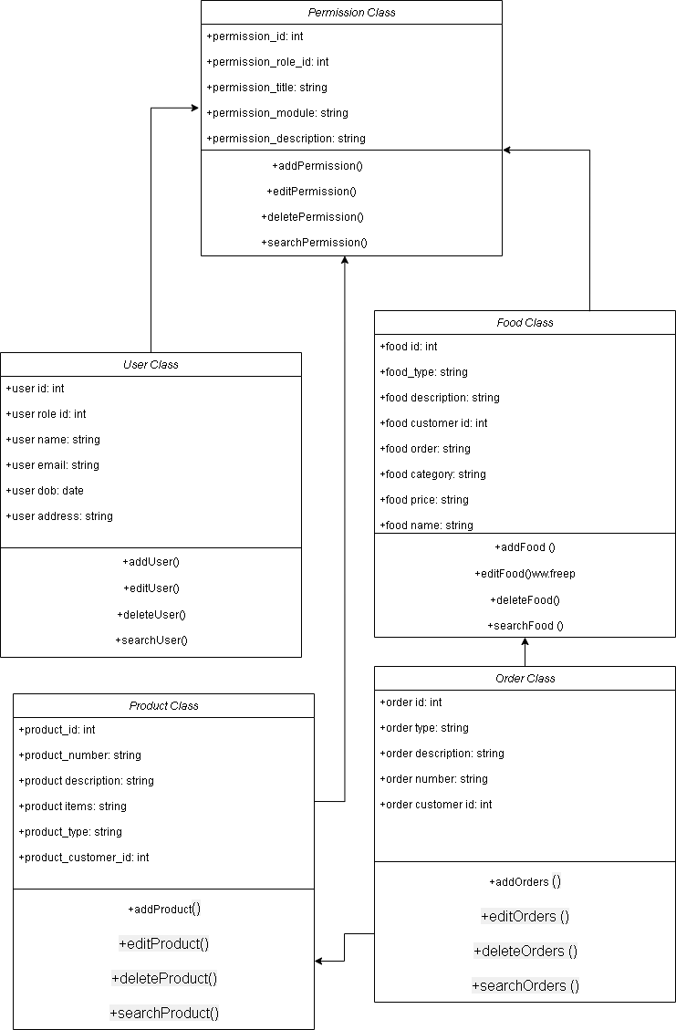

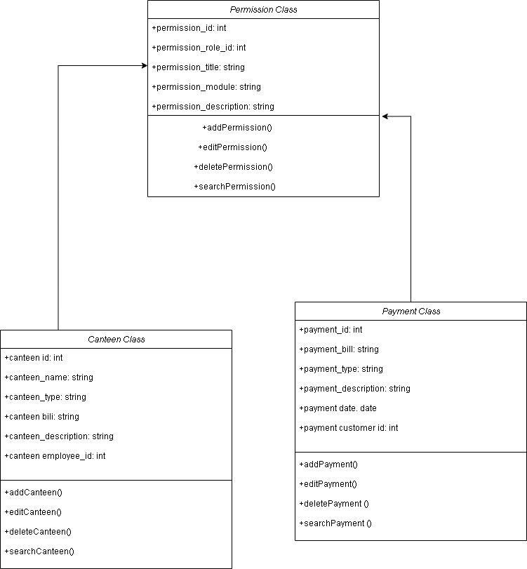

* + 1. **Use Case Diagram for Key Interactions**

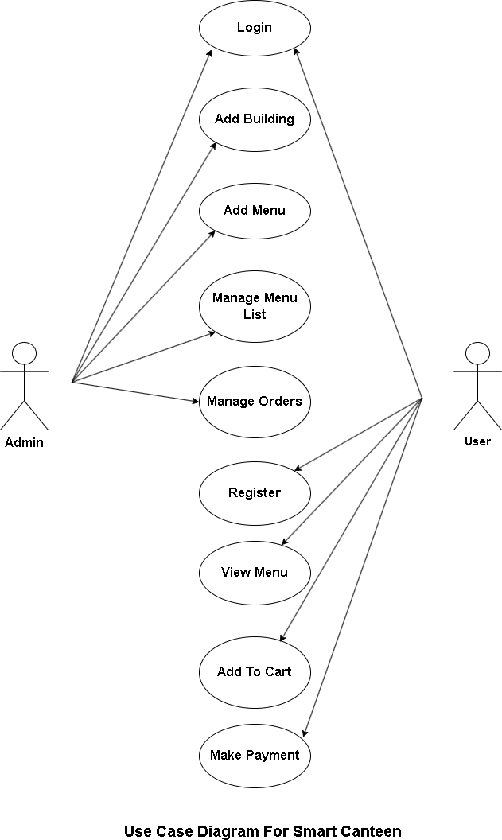

# Chapter 6: System Implementation

## Implementation Strategy for Smart Canteen Application

* + 1. **Requirements Gathering:**
       - **Objective:** Gather comprehensive requirements for the Smart Canteen system.
       - **Activities:** Interact with stakeholders, understand user needs, and create mockups using HTML/CSS for visual representation of the application's layout and structure.
       - **Tools Used:** HTML and CSS for creating static web page mockups.

## System Design:

* + - * **Objective:** Design the system architecture and plan application features.
      * **Activities:** Define system architecture, integrate Bootstrap framework to enhance UI/UX, and plan for responsive design implementation.
      * **Tools Used:** Bootstrap for responsive layout design and improved UI components.

## Implementation:

* + - * **Objective:** Translate design into actual code.
      * **Activities:** Write HTML/CSS code based on the design specifications. Utilize Bootstrap classes for creating responsive elements, navigation bars, forms, buttons, etc.
      * **Tools Used:** HTML, CSS, and Bootstrap within NetBeans IDE for coding and development.

## Database Development (MySQL Workbench):

* + - * **Objective:** Create and design the database structure for the Smart Canteen application.
      * **Activities:** Use MySQL Workbench to design the database schema, define tables, relationships, and optimize data storage strategies.
      * **Tools Used:** MySQL Workbench for database modeling and implementation.

## Testing :

* + - * **Objective:** Integrate the developed modules and conduct thorough testing.
      * **Activities:** Integrate HTML, CSS, Bootstrap UI components with the back- end (Java) for functional testing. Verify data flow and user interactions. Perform unit testing and UI/UX testing.
      * **Tools Used:** NetBeans IDE for Java integration and manual testing procedures.

## Deployment (LocalHost):

* + - * **Objective:** Deploy the Smart Canteen Web Application for actual usage.
      * **Activities:** Prepare the application for deployment on a web server or hosting platform. Ensure compatibility and optimal performance.
      * **Tools Used:** Web server hosting for application deployment.

## Maintenance:

* + - * **Objective:** Provide ongoing maintenance and support for the deployed application.
      * **Activities:** Address user feedback, fix bugs, perform updates, and provide technical support as required.
      * **Tools Used:** Continuous monitoring and issue resolution based on user feedback and system performance metrics.

## Java Source Code Samples User Login Page-

<!DOCTYPE html>

<html lang="en">

<head>

<meta charset="utf-8">

<meta content="width=device-width, initial-scale=1.0" name="viewport">

<title>User Signup</title>

<meta content="" name="description">

<meta content="" name="keywords">

<!-- Favicons -->

<link href="assets/img/Logo Smart.png" rel="icon">

<link href="assets/img/Smart Canteen.png" rel="apple-touch-icon">

<!-- Google Fonts -->

<link href="https://fonts.gstatic.com" rel="preconnect">

<link href="https://fonts.googleapis.com/css?family=Open+Sans:300,300i,400,400i,600,600i,700,7 00i|Nunito:300,300i,400,400i,600,600i,700,700i|Poppins:300,300i,400,400i,500,500i,600,60

0i,700,700i" rel="stylesheet">

<!-- Vendor CSS Files -->

<link href="assets/vendor/bootstrap/css/bootstrap.min.css" rel="stylesheet">

<link href="assets/vendor/bootstrap-icons/bootstrap-icons.css" rel="stylesheet">

<link href="assets/vendor/boxicons/css/boxicons.min.css" rel="stylesheet">

<link href="assets/vendor/quill/quill.snow.css" rel="stylesheet">

<link href="assets/vendor/quill/quill.bubble.css" rel="stylesheet">

<link href="assets/vendor/remixicon/remixicon.css" rel="stylesheet">

<link href="assets/vendor/simple-datatables/style.css" rel="stylesheet">

<!-- Template Main CSS File -->

<link href="assets/css/style.css" rel="stylesheet">

<style>

/* Custom styles for signup page */ body {

margin: 0;

padding: 0; overflow: hidden;

background-color: #3b5d50; /* Set background color for the whole body */

}

/* ... (existing styles) ... */

/* Adjustments for signup form */

.form-signup {

padding: 30px; max-width: 400px; width: 100%;

}

.form-signup .form-label { font-weight: 500;

}

.form-signup .btn-primary {

background-color: #3b5d50 !important; border-color: #3b5d50 !important;

}

.form-signup .btn-primary:hover { background-color: #2d473c !important; border-color: #2d473c !important;

}

/* Custom styles for moving dots */

.section.signup::before,

.section.signup::after { content: '';

position: absolute;

width: 12px; /* Adjust the dot size */

height: 12px; /* Adjust the dot size */ background-color: #fff;

border-radius: 50%;

animation: dots 12s linear infinite; /* Adjust the animation speed */

}

.section.signup::before { top: 5%;

left: 5%;

animation-delay: 0s; /* Delay for the first dot */

}

.section.signup::after { top: 70%;

left: 70%;

animation-delay: 2s; /* Delay for the second dot */

}

@keyframes dots { 0% {

transform: translate(0, 0);

opacity: 1;

} 100% {

transform: translate(150vw, 150vh); /* Adjust the direction and distance */ opacity: 0;

}

}

/* Additional dots with different directions */

.section.signup::after {

animation: dots2 8s linear infinite; /* Adjust the animation speed */

}

@keyframes dots2 { 0% {

transform: translate(0, 0);

opacity: 1;

} 100% {

transform: translate(-150vw, -150vh); /* Adjust the direction and distance */ opacity: 0;

}

}

</style>

</head>

<body>

<main>

<div class="container">

<section class="section signup min-vh-100 d-flex flex-column align-items-center justify- content-center py-4">

<div class="container">

<div class="row justify-content-center">

<div class="col-lg-4 col-md-6 d-flex flex-column align-items-center justify-content- center">

<div class="card mb-3">

<div class="card-body form-signup">

<div class="pt-4 pb-2">

<h5 class="card-title text-center pb-0 fs-4">Sign Up</h5>

</div>

<form class="row g-3 needs-validation" novalidate id="signupForm">

<div class="col-12">

<label for="username" class="form-label">Username</label>

<input type="text" name="username" class="form-control" id="username"

required>

<div class="invalid-feedback">Please enter a username.</div>

</div>

<div class="col-12">

<label for="phone" class="form-label">Phone Number</label>

<input type="tel" name="phone" class="form-control" id="phone" required>

<div class="invalid-feedback">Please enter a phone number.</div>

</div>

<div class="col-12">

<label for="email" class="form-label">Email</label>

<input type="email" name="email" class="form-control" id="email" required>

<div class="invalid-feedback">Please enter a valid email.</div>

</div>

<div class="col-12">

<label for="password" class="form-label">Password</label>

<input type="password" name="password" class="form-control" id="password" required>

<div class="invalid-feedback">Please enter a password.</div>

</div>

<div class="col-12">

<label for="confirmPassword" class="form-label">Confirm Password</label>

<input type="password" name="confirmPassword" class="form-control" id="confirmPassword" required>

<div class="invalid-feedback">Passwords do not match.</div>

</div>

<div class="col-12">

<button class="btn btn-primary w-100" type="submit">Sign Up</button>

</div>

</form>

</div>

</div>

</div>

</div>

</div>

</section>

</div>

</main><!-- End #main -->

## Integration of Security Measures

Integrating security measures into a NetBeans/MySQL Workbench environment involves implementing various strategies to enhance the security of both the application code and the database. Here are steps you can take:

## Parameterized Queries and Prepared Statements:

* Utilize parameterized queries and prepared statements in Java code to prevent SQL injection attacks. Parameterized queries help sanitize user inputs before executing SQL queries, ensuring database security against malicious inputs.

## Secure Authentication and Authorization:

* Implement secure authentication mechanisms in your Java application using industry- standard practices like hashing and salting passwords before storing them in the MySQL database. Implement role-based access control (RBAC) for authorized access to different parts of the application.

## Database Security Configuration:

* Configure MySQL server settings to enforce strict security measures.
* This includes setting strong passwords for database accounts, restricting access based on IP addresses, and disabling unnecessary features or ports that could pose security risks.

# Chapter 7: System Testing

## Unit Testing of Modules and Functionalities

* + 1. **Testing Environment Setup:**
       - Configure a testing environment within NetBeans IDE. Use testing frameworks like JUnit or TestNG for Java to create test classes.

## Isolated Testing of Java Classes (Servlets/Controllers):

* + - * Write unit tests for individual Java classes that handle business logic, request processing, and database interactions. Test different functionalities like user authentication, order processing, data validation, etc.
      * Mock dependencies or use mocking frameworks where necessary to isolate the classes being tested.

## HTML/CSS/Bootstrap Component Testing:

* + - * Validate the HTML structure, CSS styling, and Bootstrap components for compatibility, responsiveness, and correct rendering across different browsers and devices.
      * Ensure that Bootstrap components such as navigation bars, buttons, forms, etc., behave as expected and align with the design mockups.

## JSP Page Testing:

* + - * Test JSP pages for dynamic content rendering, correct integration of Java code within HTML, and proper data presentation retrieved from the backend (Servlets or Controllers).
      * Validate the flow of control between JSP pages and Servlets to ensure correct data processing and navigation.

## Database Interaction Testing (MySQL Workbench):

* + - * Test database interactions by creating test data and executing CRUD (Create, Read, Update, Delete) operations.
      * Validate that data retrieval, insertion, and updates are correctly reflected in the database by inspecting through MySQL Workbench.

## Integration Testing for Seamless Operations

* + 1. **End-to-End Workflow Testing:**
       - Verify the complete workflow of the Smart Canteen system, including user registration, login, menu browsing, order placement, payment processing, and order fulfillment.
       - Test these workflows using different scenarios, ensuring that data flows correctly between HTML, JSP, Servlets, and the database.

## Front-end and Back-end Interaction Testing:

* + - * Test the interaction between the front-end (HTML, Bootstrap) and back-end (Servlets, Java logic) to ensure that user inputs are correctly processed, and the responses are accurately reflected in the UI.
      * Verify that data fetched from the database via MySQL Workbench is displayed correctly in the HTML pages.

## Data Integrity and Database Testing:

* + - * Validate the integrity of data between the application and the MySQL database. Check if data insertion, updates, and retrievals performed by the application accurately reflect in the database tables.
      * Ensure that database transactions initiated by the application are appropriately committed or rolled back as required.

## Session Management and State Handling:

* + - * Test session management and state handling mechanisms across multiple pages. Ensure that user sessions are maintained correctly, and the application behaves consistently under different user interactions.

# Chapter 8: User Interface Samples

## Homepage of Smart Canteen Application

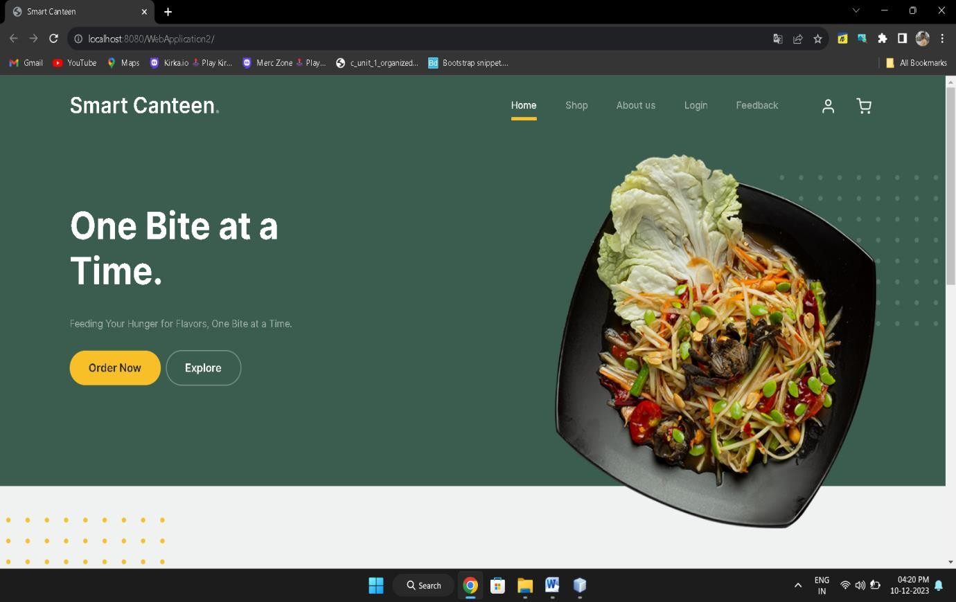

## User Registration and Profile Setup

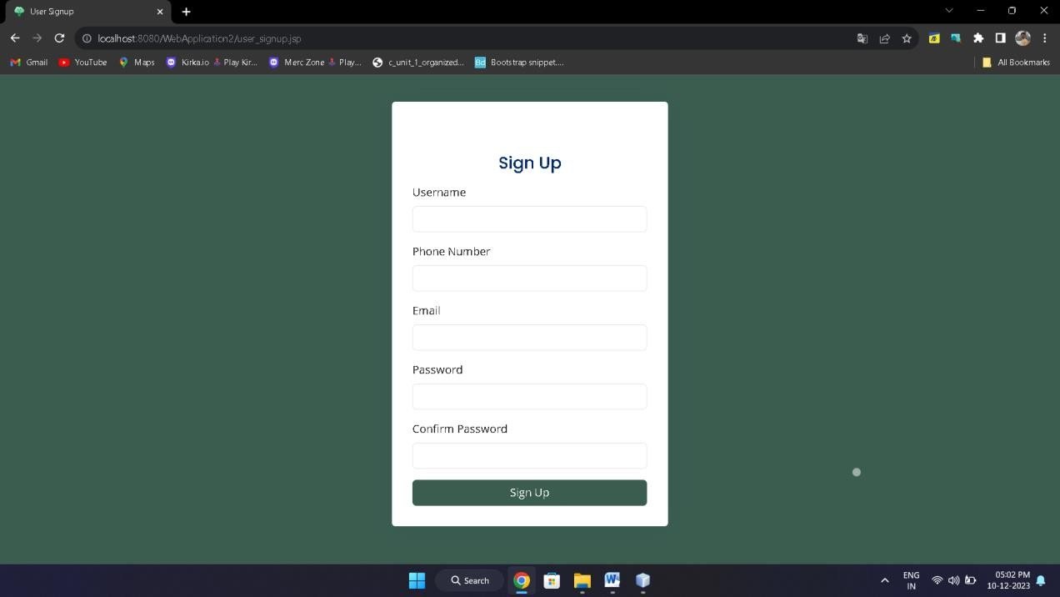

## Login Interface for User

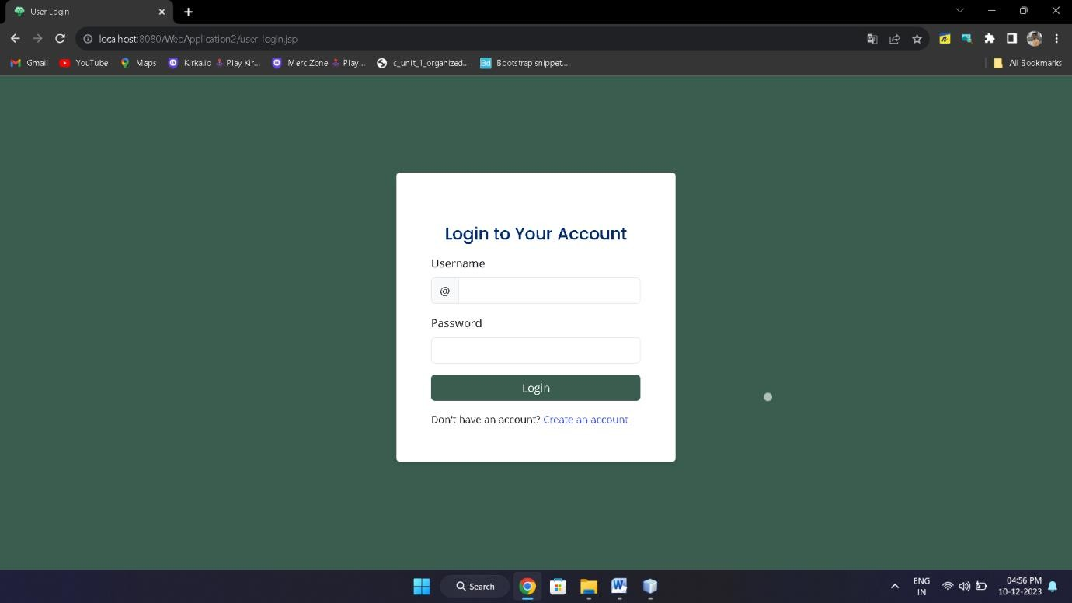

## Add Menu Screens.

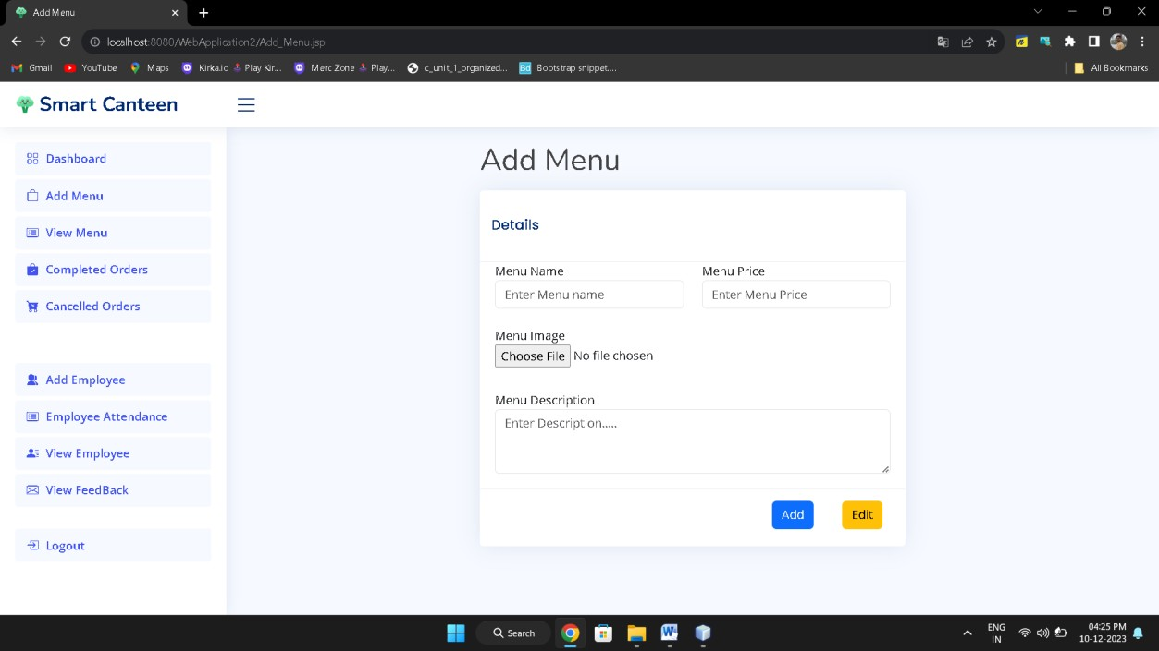

## Add Employee Screens.

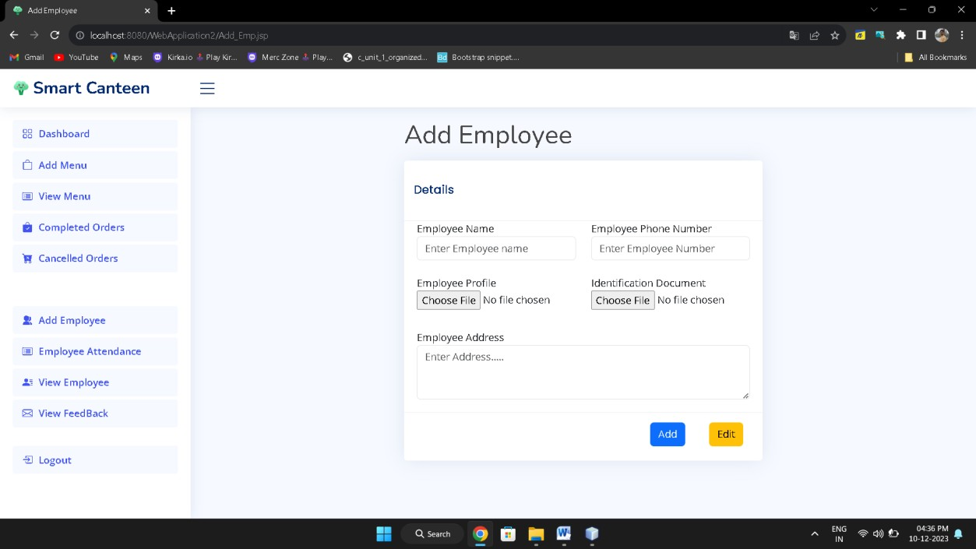

## Order Confirmation

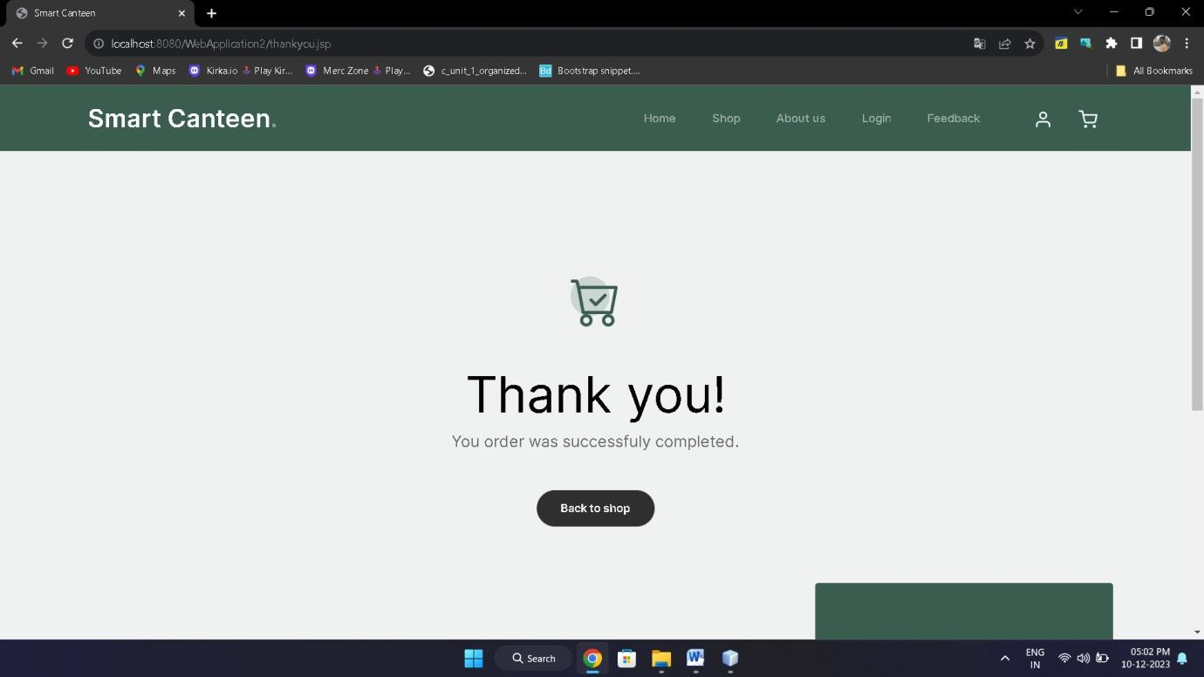

# Conclusive and Future Enhancement

**Conclusion:**

The development of the Smart Canteen Java web application using HTML, Bootstrap, JSP, Servlets in NetBeans IDE, and MySQL Workbench has resulted in a sophisticated and user-friendly solution. This application aims to streamline canteen operations, enhancing user experiences and operational efficiency.

The Smart Canteen application offers a seamless interface for users to browse menus, place orders, and process transactions. Leveraging Java technologies, it ensures a responsive and visually appealing design using HTML, CSS, and Bootstrap. The integration of Servlets with MySQL Workbench enables efficient data management and retrieval, ensuring the application's robust functionality.

# Future Enhancements:

While the current iteration of the Smart Canteen application provides a solid foundation, there exist avenues for future enhancements and improvements:

* + 1. **Mobile Application Development:** Consider developing a mobile version or a dedicated mobile application for the Smart Canteen to enhance accessibility and convenience for users.
    2. **Enhanced User Features:** Introduce personalized user profiles, order history, and preferences to offer a more tailored experience. Implement features like feedback/rating systems for menu items or services.
    3. **Integration with Payment Gateways:** Integrate secure payment gateways to facilitate seamless online transactions and multiple payment options, ensuring user convenience.
    4. **Real-time Updates and Notifications:** Implement real-time order status updates and push notifications to keep users informed about their orders' progress.
    5. **Advanced Analytics and Reporting:** Introduce analytics tools to gather insights into user behaviors, popular menu items, peak hours, and trends. Use this data for strategic decision-making and improving services.
    6. **Accessibility and Internationalization:** Enhance the application's accessibility features and consider incorporating multi-language support for broader user reach.

# Biblography

[www.Google.com](http://www.Google.com/) https://chat.openai.com https://[www.wikipedia.org](http://www.wikipedia.org/) https://app.diagrams.net/